
Year 8

Term 1 Test

Resources allowed: A handwritten A4 notes page double sided

Name: __________________ Class: _____ Total Time: 50 minutes Calculator Allowed Mark /36

CALCULATOR ALLOWED SECTION

- [3 marks]
Complete the following conversions:
- 3m = _____________mm
- 2cm² = ___________mm²
- 5000cm³ = ____________m³

- [1, 1 = 2 marks]
The perimeter of a rectangle is 36 m.
- Draw a rectangle with this perimeter and mark in a possible length and width.

- Find the area of your rectangle.

- [1, 1, 2, + 1 mark for all units = 5 marks]

Find the perimeter of the following shapes. Show your working clearly and giving your answers correct to two decimal places when necessary:
Shape | Working and Answer
a)
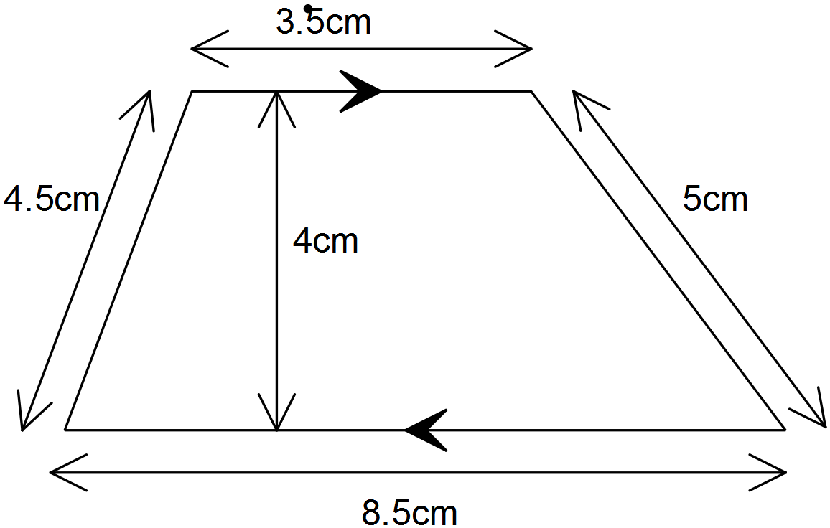

b)
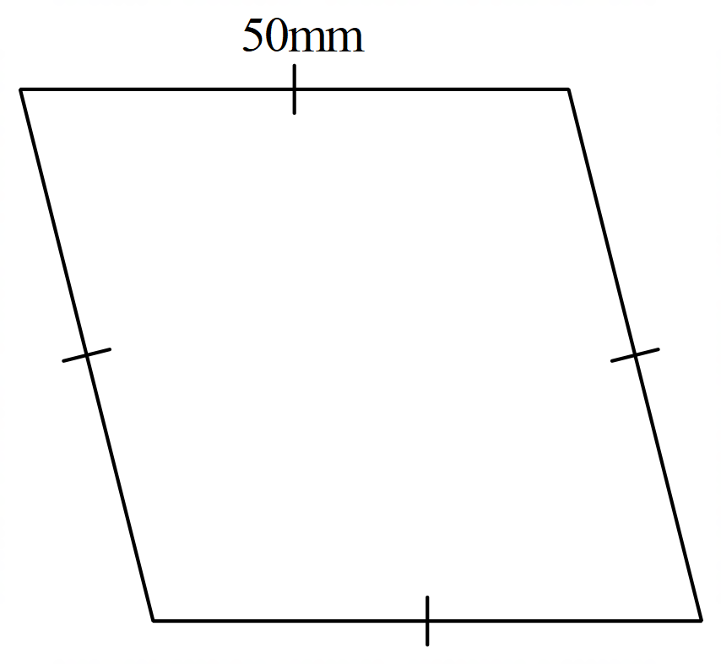

c)
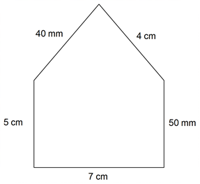

- [1, 2, 1 = 4 marks]
Find the area of the following shapes. Show your working clearly and give your answers correct to two decimal places when necessary.
Shape | Working and Answer
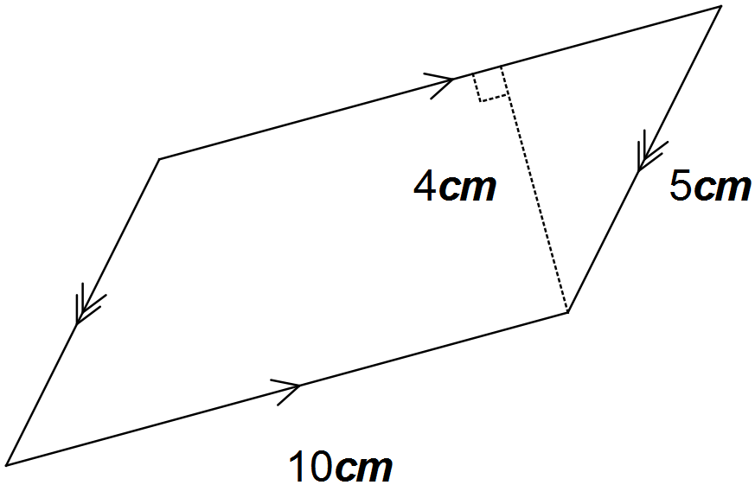a)

b)
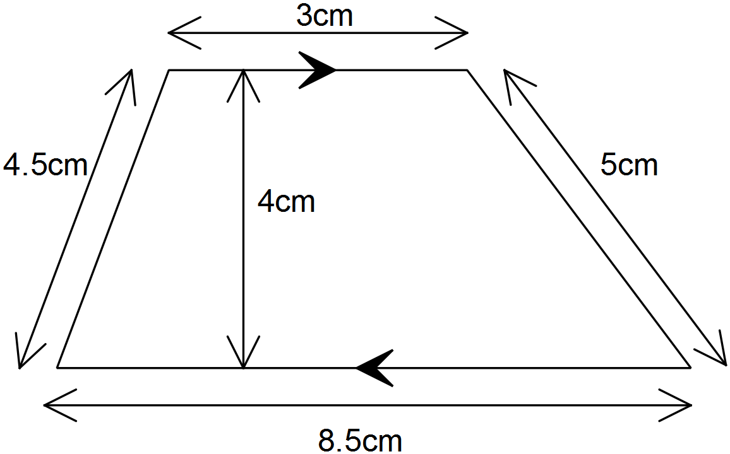

c)
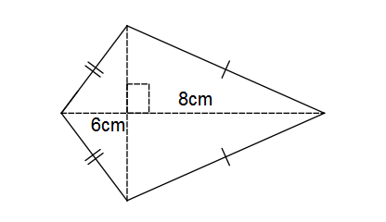

- [2, 2 = 4 Marks]
Calculate the volume of this prism:
Shape | Working and Answer
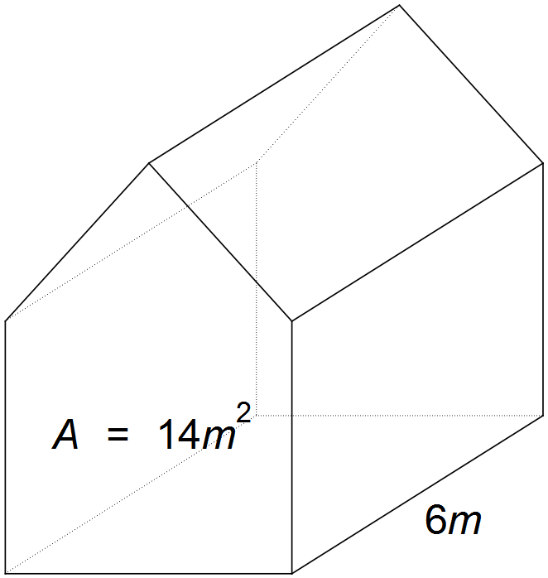

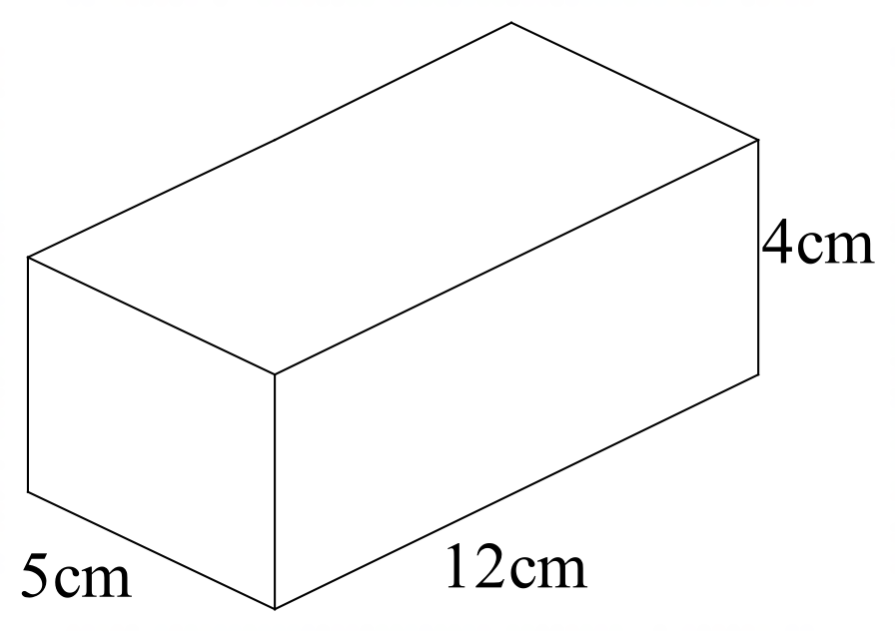

- [2, 2 = 4 marks]
- Riley’s tent makes a triangular prism when it is put up. He knows the tent is 1.2m wide and 1.5m high. He does not know what the volume of the tent is, so he measures the length as 180cm. What is the volume of the tent?

- What would the length of the Ethan’s tent be for the volume to be 2m³?

- [1, 2, 2 = 5 marks]
Here are the results of a survey of cars passing the school.
Colour | Red | Blue | Yellow | Black | White
Number of cars | 7 | 19 | 4 | 23 | 27

- What is the experimental probability of a red car passing the school?

- Describe the complement of the event in part (a) and find its experimental probability of occurring.

- If a student was to repeat this survey again at the same time next week, recording colours until 100 cars had passed, how many of them would she expect to be yellow?

- [1, 1, 1 = 3 marks]
Write the complementary event for the following:

- It will rain today

- Rolling a 6-sided die and getting a 5

- You catch the bus home

- [1, 1 = 2 marks]
There are 10 counters in a bag. The counters are numbered 1, 2, 3, 4, 5, 6, 7, 8, 9, 10.
If one counter is drawn out at random, what is the probability that it is a counter:

- with an odd number

- that is greater than 6

- [2 mark]
The probability of selecting a blue marble from a bag of marbles is 0.3.

- Find P (Not blue)

- How many marbles could there be in the bag

- [1, 1 = 2 marks]
If we write the letters from the word MATHEMATICS on separate pieces of paper and place them in a bag, the probability of selecting an M is: P(M) = $\frac{2}{11}$.
a) Write down a word which has P(D) = $\frac{1}{4}$.

b) Write down a word which has P(vowel) > P(consonant).

